Health Insurance Cost Analysis & Risk Intelligence Report

Executive Summary
This report evaluates customer demographics, lifestyle risk factors, and healthcare cost patterns across 1,338 insurance policyholders.
The objective is to identify the primary drivers of insurance charges and provide actionable business recommendations that support pricing optimization, risk segmentation, and long-term profitability.
The analysis combines exploratory data analysis, statistical validation, and business-focused interpretation to uncover factors that significantly influence healthcare expenditures.

Business Objective
The primary objective of this analysis is to identify the factors that contribute most significantly to insurance costs and to determine whether customer risk characteristics should influence pricing and customer management strategies.

Key business goals include:

• Understanding healthcare cost drivers
• Improving customer risk segmentation
• Supporting data-driven premium pricing
• Identifying opportunities for cost reduction
• Enhancing underwriting decision-making

Exploratory Data Analysis

Customer Demographics Analysis

Age Distribution
sns.histplot(df['age'], kde=True)
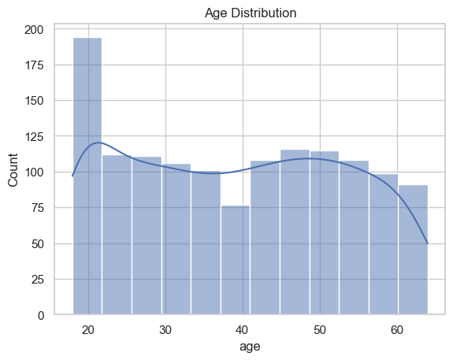
The age distribution is relatively uniform, with most individuals between 20 and 60 years.

Smoker Distribution
sns.countplot(x='smoker', data=df)
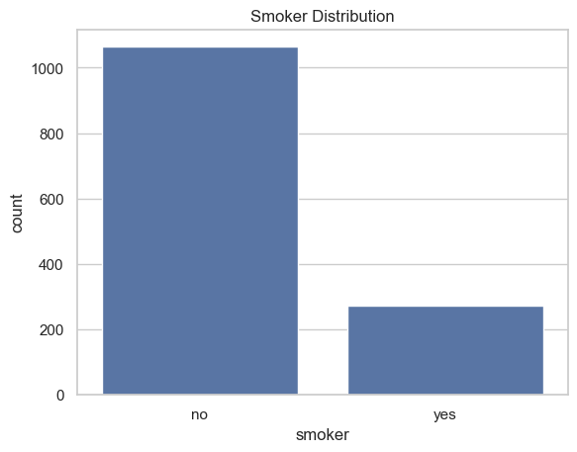
Most individuals are non-smokers (79.5%), while smokers account for about 20.5%.

Region Distribution
sns.countplot(x='region', data=df)
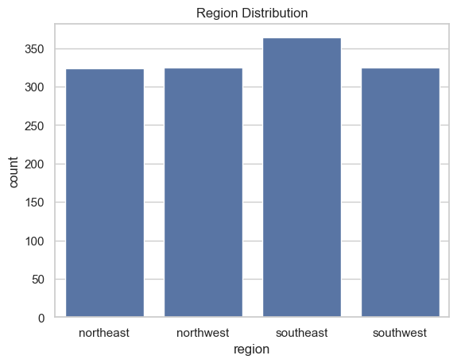
The dataset is evenly distributed across all four regions.

Insurance Cost Distribution

Charges Distribution
sns.histplot(df['charges'], kde=True)
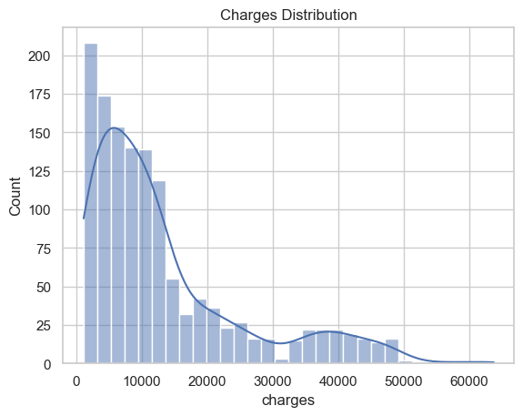
Charges are highly right-skewed, indicating that a small number of individuals incur very high medical costs (Hunter, 2007).

Risk Segment Analysis

Age vs Charges
sns.scatterplot(x='age', y='charges', data=df)
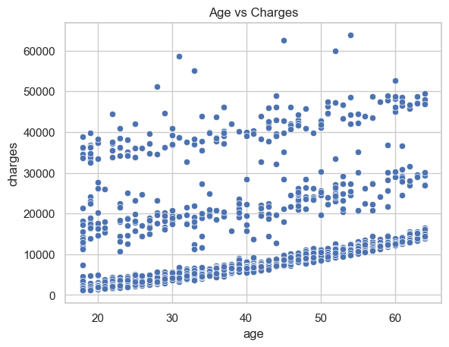
There is a positive relationship between age and charges, indicating that older individuals tend to have higher medical expenses (Waskom, 2021).

Smoker vs Charges
sns.boxplot(x='smoker', y='charges', data=df)
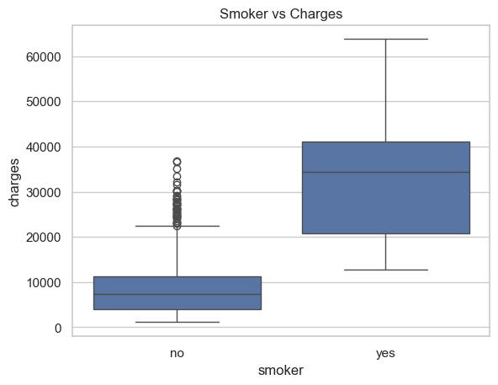
Smokers have significantly higher insurance charges compared to non-smokers (Harris et al., 2020).

Smoker vs Age
sns.boxplot(x='smoker', y='age', data=df)
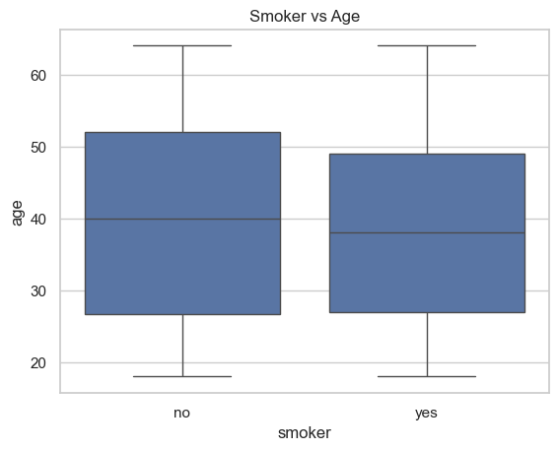
There is no major difference in age distribution between smokers and non-smokers.

Regional Performance Analysis

Region vs Charges
sns.boxplot(x='region', y='charges', data=df)
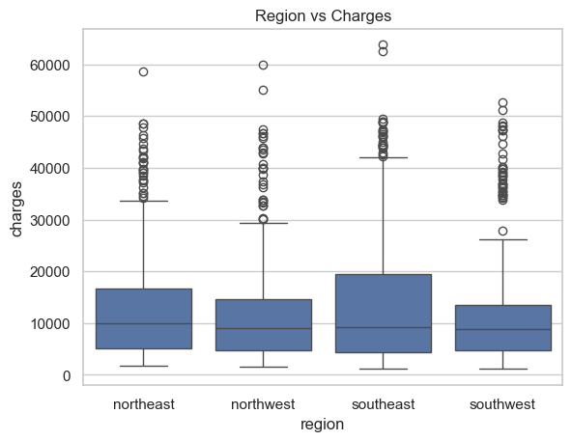
Charges vary slightly across regions, but no strong pattern is observed.

Region vs Age
plt.figure()
sns.boxplot(x='region', y='age', data=df)
plt.title("Region vs Age")
plt.show()
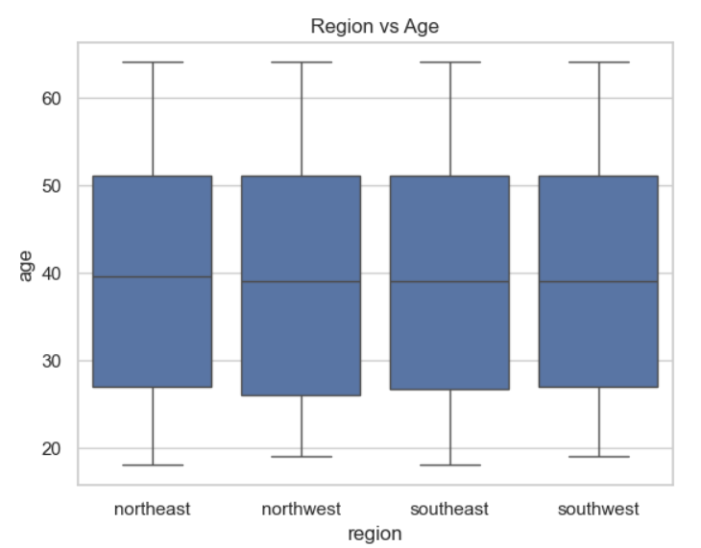
There is no substantial difference in age distribution across the four regions. The median age and overall spread of ages appear relatively similar, suggesting that age is fairly balanced among the regions.

Cost Driver Assessment
sns.heatmap(df.corr(numeric_only=True), annot=True)
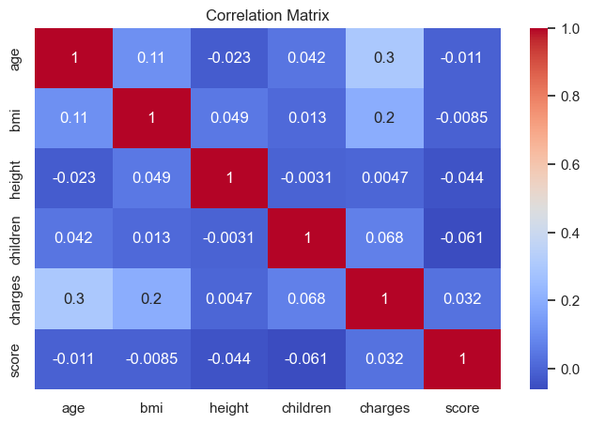
The correlation assessment was conducted to identify variables that have the strongest relationship with insurance charges.

The analysis revealed that smoking status is the strongest predictor of healthcare costs, followed by age and BMI. These findings indicate that behavioral and demographic risk factors have a greater influence on insurance expenses than geographic location.

Financial & Customer Metric Summary
df[['age', 'bmi', 'charges', 'score']].describe()

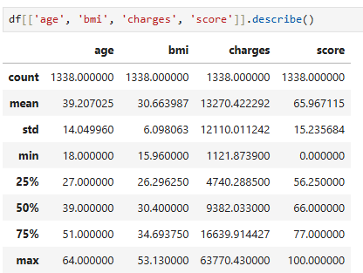

df[['age', 'bmi', 'charges', 'score']].agg(['mean','median','std','var','min','max'])

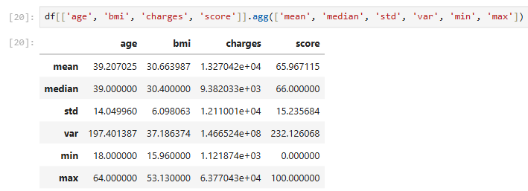
- Mean Age: 39.21
- Mean BMI: 30.66
- Mean Charges: 13,270
- Mean Score: 65.97
The numerical profile indicates substantial variability in healthcare charges, suggesting the existence of distinct low-risk and high-risk customer groups.

Average customer age was 39 years, while average BMI was approximately 31. The average insurance charge exceeded $13,000, highlighting the financial significance of risk-based customer segmentation.

Customer Segmentation Summary
for col in ['sex', 'smoker', 'region', 'Level']:
print(col)
print(df[col].value_counts())
print(df[col].value_counts(normalize=True) * 100)
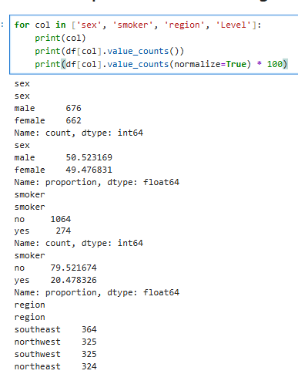
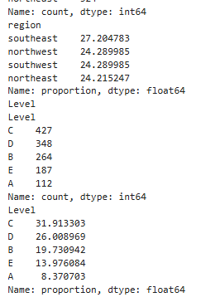

- Gender distribution is balanced
- Majority are non-smokers
- Regions are evenly distributed
- Most individuals fall in Level C

Statistical Validation Analysis

Business Question
Does smoking behavior materially increase healthcare costs and justify differentiated risk-pricing strategies?
Methodology
An Independent Samples T-Test was conducted to validate whether insurance charges differ significantly between smokers and non-smokers.
Reject Null Hypothesis
The statistical analysis confirms a substantial and statistically significant difference in healthcare costs between smokers and non-smokers.
The extremely small p-value indicates that the observed cost difference is highly unlikely to be due to random variation.
Smoking status therefore represents one of the most influential risk factors affecting insurance charges.

PARAMETRIC TEST CODE
An independent samples t-test was conducted to compare insurance charges between smokers and non-smokers.
smoker = df[df['smoker'].str.lower() == 'yes']['charges']
non_smoker = df[df['smoker'].str.lower() == 'no']['charges']
t_stat, p_value = stats.ttest_ind(smoker, non_smoker, equal_var=False)
print("T-statistic:", t_stat)
print("P-value:", p_value)
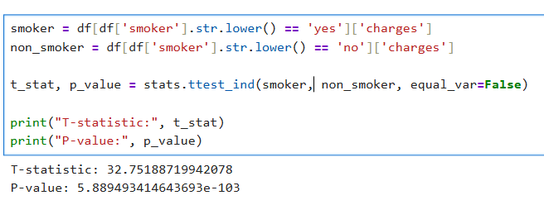
The results of the test are:
- T-statistic = 32.75
- P-value = 5.89e-103

Interpretation
The Independent Samples t-test was conducted to evaluate whether there is a statistically significant difference in insurance charges between smokers and non-smokers.
The null hypothesis (H0) states that there is no difference in mean insurance charges between the two groups. The alternative hypothesis (H1) states that there is a significant difference in mean insurance charges between smokers and non-smokers.
Since the p-value (5.89e-103) is significantly less than the significance level of 0.05, the null hypothesis is rejected. This provides strong statistical evidence that insurance charges differ between smokers and non-smokers.

Answer to Research Question
Yes, smokers have significantly higher insurance charges compared to non-smokers. The results of the independent samples t-test confirm that the difference in mean charges between the two groups is statistically significant.

Business Benefit
This finding provides valuable business insight for insurance companies. Since smokers are associated with significantly higher insurance charges, the company can adjust premium pricing to reflect higher risk levels.

Additionally, the organization can design targeted health and wellness programs for smokers to reduce long-term healthcare costs. This supports better risk management, improved profitability, and more data-driven pricing strategies.

Recommendation
Based on the results of the analysis, the insurance company should implement a risk-based pricing strategy where smokers are charged higher premiums due to significantly higher insurance costs.

In addition, the company should introduce targeted health improvement programs such as smoking cessation support and wellness incentives. These initiatives can help reduce long-term healthcare costs and improve overall risk management.

Furthermore, customer segmentation should be enhanced to better classify high-risk individuals and adjust pricing models accordingly.

Limitations
This analysis has several limitations. The dataset does not include important health-related variables such as medical history, chronic diseases, physical activity levels, or genetic risk factors, which may also influence insurance charges.

Additionally, environmental and lifestyle factors outside the dataset are not considered. The analysis is also based on a single dataset, which may limit the generalizability of the findings to other populations or insurance markets.

Regional Cost Comparison

Business Question
Do geographic regions significantly influence healthcare costs within the insured population?

Fail to reject null hypothesis

The analysis found no statistically significant difference in insurance charges across geographic regions.

This suggests that customer location is not a primary driver of healthcare costs and may not require region-specific pricing adjustments.

Key Business Findings

• Smoking status is the strongest predictor of insurance charges.
• Healthcare costs increase with age.
• Insurance charges exhibit significant variability, indicating the presence of high-cost customer segments.
• Geographic location has minimal impact on healthcare costs.
• Behavioral risk factors provide stronger predictive value than regional factors.

Strategic Recommendations

• Implement risk-adjusted premium pricing models.
• Develop targeted smoking cessation and wellness programs.
• Introduce customer risk scoring for underwriting decisions.
• Expand predictive analytics initiatives for future cost forecasting.
• Focus segmentation efforts on customer behavior and health risk indicators rather than geographic location.

Business Impact

Expected business benefits include:

• Improved pricing accuracy
• Better risk assessment
• Lower claims volatility
• Improved underwriting performance
• More effective customer segmentation
• Increased profitability and operational efficiency

NONPARAMETRIC TEST METHOD
Kruskal-Wallis Test

Relevant Variables
- Region (categorical)
- Charges (numerical)

JUSTIFICATION FOR NONPARAMETRIC TEST
Kruskal-Wallis test is used because it compares more than two independent groups without assuming normal distribution.

DEVELOP NONPARAMETRIC HYPOTHESES
- H0: All regions have equal distribution of charges
- H1: At least one region differs

NONPARAMETRIC TEST CODE
regions = df['region'].unique()
groups = [df[df['region'] == region]['charges'] for region in regions]

stat, p_value = stats.kruskal(*groups)
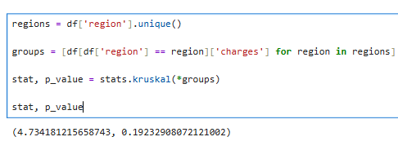
- Statistic = 4.73
- p-value = 0.192

NONPARAMETRIC HYPOTHESIS SUPPORT
Since the p-value is greater than 0.05, we fail to reject the null hypothesis.

ANSWER TO NONPARAMETRIC RESEARCH QUESTION

There is no significant difference in insurance charges across regions.

BENEFIT OF NONPARAMETRIC DATA ANALYSIS
This suggests that location does not strongly influence insurance pricing, allowing uniform pricing strategies across regions.

Recommendation
The company should focus more on individual risk factors (like smoking) rather than geographic location.

Limitations
- Regional healthcare cost differences are not deeply explored
- Sample size per region may affect results

References

Harris, C. R., Millman, K. J., van der Walt, S. J., et al. (2020). Array programming with NumPy. Nature, 585(7825), 357–362.

Hunter, J. D. (2007). Matplotlib: A 2D graphics environment. Computing in Science & Engineering, 9(3), 90–95.

McKinney, W. (2010). Data structures for statistical computing in Python. Proceedings of the 9th Python in Science Conference.

Virtanen, P., Gommers, R., Oliphant, T. E., et al. (2020). SciPy 1.0: Fundamental algorithms for scientific computing in Python. Nature Methods, 17, 261–272.

Waskom, M. L. (2021). Seaborn: Statistical data visualization. Journal of Open Source Software, 6(60), 3021.

Conclusion
The analysis identified smoking status as the strongest factor influencing insurance charges. Parametric testing confirmed that smokers incur significantly higher medical expenses than non-smokers. Nonparametric testing showed that regional differences do not significantly affect insurance charges. These findings provide valuable business insights that can support pricing strategies, customer risk assessment, and healthcare planning decisions.

